**Soft Computing Lab End Term Practical (2020-2021)**

**Aim: Write a program to implement Linear Separability for AND/OR operation.**

**Program:**

**## AND Operation**

# Linear Separability means that the line segemnt is able to divide the two classes of points distinguishably.

import numpy as np

import matplotlib as plt

import matplotlib.pyplot

x = np.array([0,1,0])

y = np.array([0,0,1])

plt.pyplot.scatter(x, y, c='red')

plt.pyplot.scatter(1, 1, c="blue")

plt.pyplot.xlabel('Input 1')

plt.pyplot.ylabel('Input 2')

w = -1

b = 1.5

x = np.linspace(0, 1.5)

plt.pyplot.plot(x, w*x+b, c='black')

plt.pyplot.show()

# Here the black line segment divides the blue and the red denoting classes. This concept is called Linear Separability

**Output:**

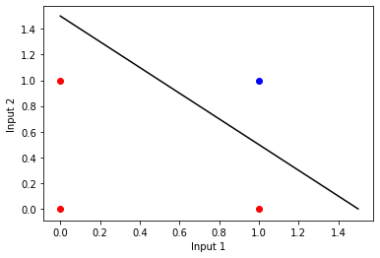

**## OR Operation**

import numpy as np

import matplotlib as plt

import matplotlib.pyplot

x = np.array([0,1])

y = np.array([0,1])

plt.pyplot.scatter(x, y, c = 'blue')

x = np.array([1,0])

y = np.array([0,1])

plt.pyplot.scatter(x, y, c = "red")

plt.pyplot.xlabel('Input 1')

plt.pyplot.ylabel('Input 2')

w = -1 #Weight

b = 1.5 #Bias

x = np.linspace(0,1.5)

plt.pyplot.plot(x, w*x+b, c='green')

plt.pyplot.show()

**Output:**

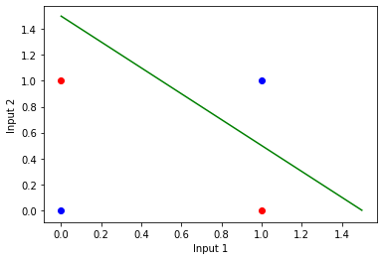

**SUBMITTED BY:**

**SNEHA DUJANIYA (170417)**